Lab_2 ;AI Use Declaration Form
Course: Introduction to Artificial Intelligence
Lab Title: Lab 1 Part A — Machine learning
Student Name: ___Monica yar malual ajhok________________________________________________
Student ID: ____10362028__________________________________________________
GitHub Repository Link: _________not applicable__________________________________
Date Submitted: _____03/07/2026_____________________________________________

1. AI Use Summary
Question | Student Response
Did you use any AI tool for this lab? | yes
Estimated percentage of work influenced by AI | 15 %
Did you attach evidence of AI use where applicable? | yes

2. Details of AI Use
Complete the table below for each AI tool used. Add more rows where necessary.
Name of AI Tool Used | Purpose for Using the Tool | Prompt or Instruction Given to the Tool | Part(s) of the Work Influenced by the Tool | How I Verified, Edited, or Improved the AI Output
copilot | To explain ML concepts and correct Python code | "To explain ML concepts and correct Python code | Data exploration, regression explanation, code debugging | I ran the code in Jupyter, checked outputs, rewrote explanations in my own words

3. Attachment of AI Output Evidence
Where required, attach evidence of AI use. Tick all that apply. Add more rows where necessary.
Evidence Type | Attached? (Yes, No, N/A) | File Name
AI-generated draft | yes | ml_draft.txt
Prompt history | yes | N/A
Screenshot of AI interaction | yes | Copilot
Exported AI conversation | no | N/A
AI-generated code snippet | yes | Regression _code
Revised version showing student input | yes | Regression _code

4. Student Declaration
I declare that:
Declaration Statement | Response (Yes/No)
The submitted work is my own work. | yes
Any use of AI tools has been clearly declared in this form. | yes
The prompts, instructions, and AI-generated outputs have been disclosed where applicable. | yes
I reviewed, tested, edited, and improved any AI-generated content before submission. | yes
My AI usage does not exceed 25% of the entire work. | yes
I understand that undeclared or excessive AI use may be treated as academic misconduct. | yes

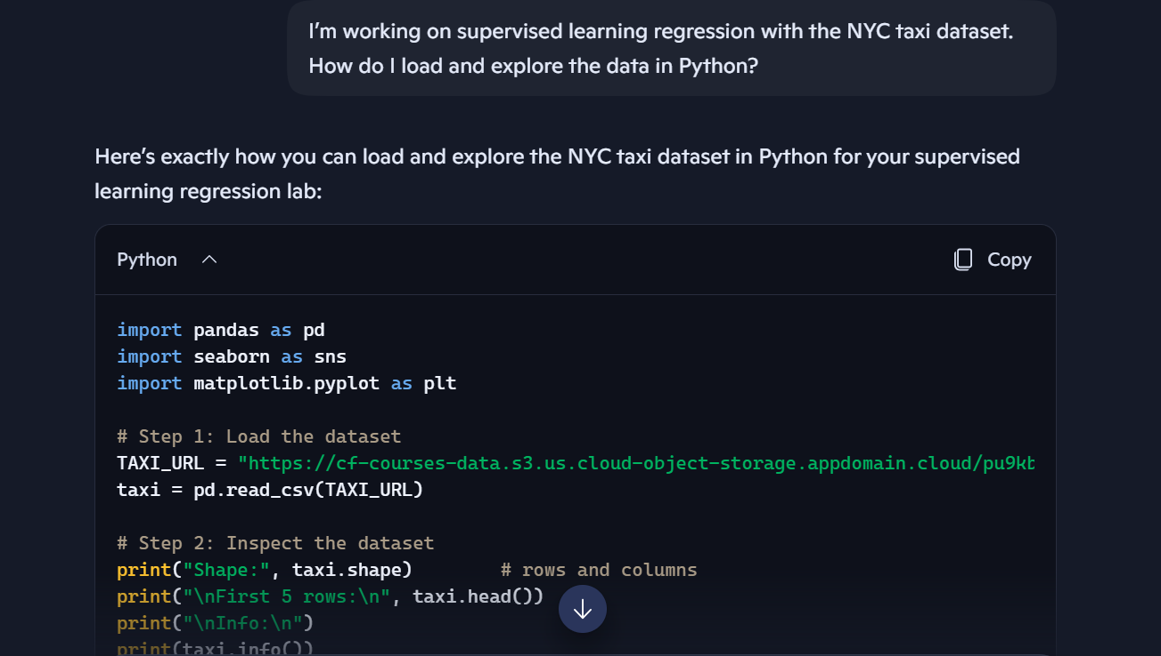
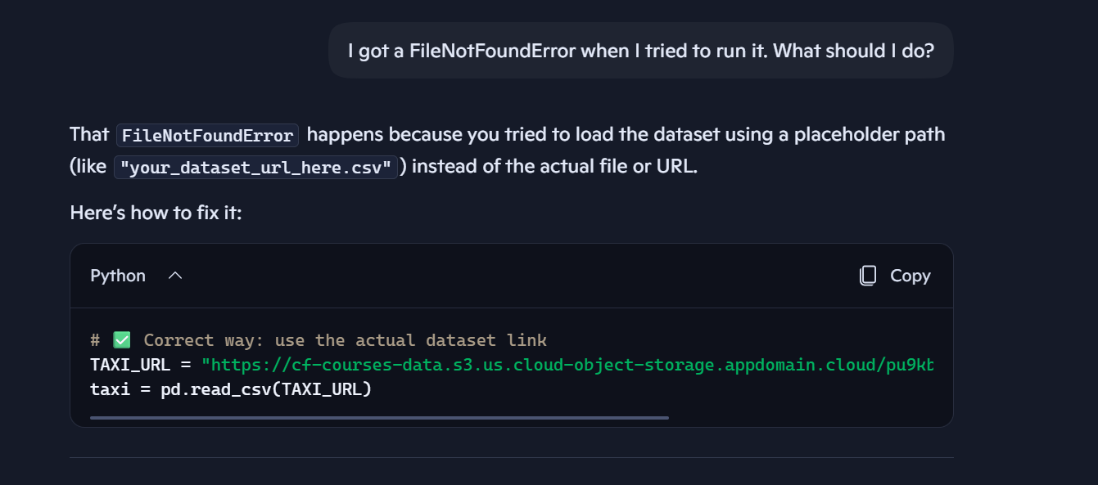
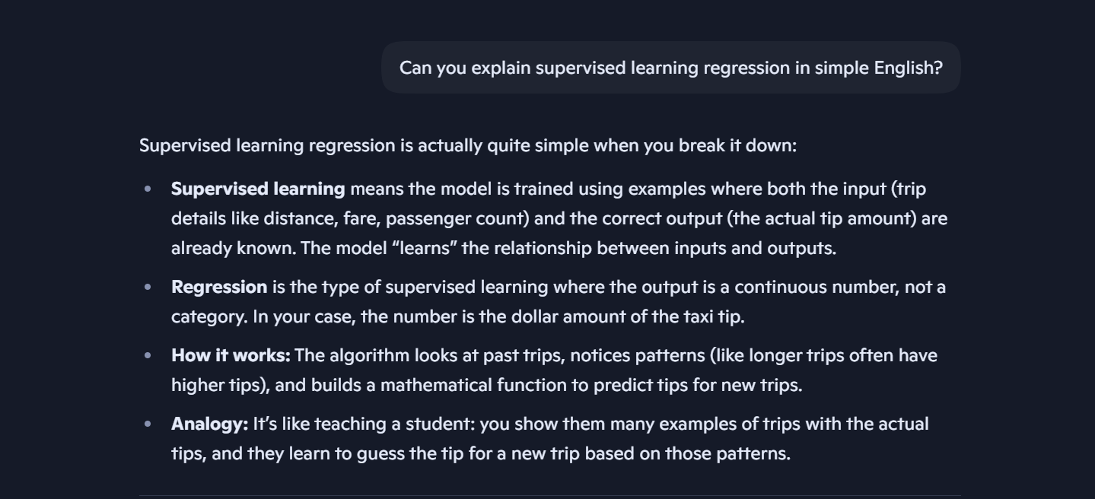
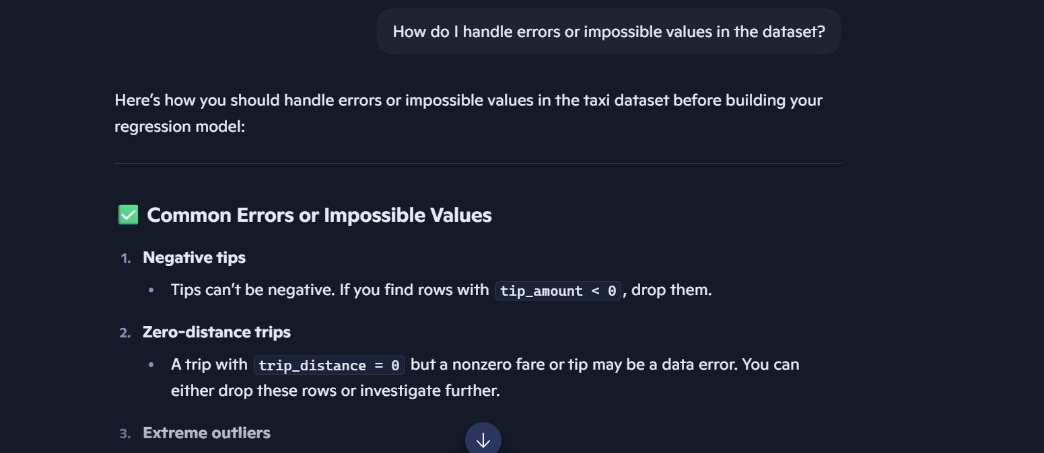

Student Signature: __monica yar malual ajhok_________________________________________
Date: ________03/07/2026___________________________________

